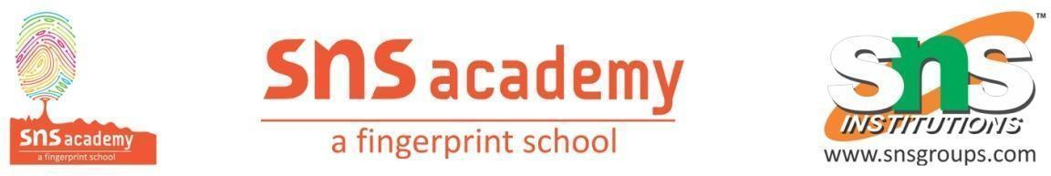

Lesson 11
Off we go - Transport
Land, Water, Air Transports
https://www.olympiadgenius.com/study-material/grade-2-Science-Modes-and-means-of-transport/?_id=962

